**A Smart Garbage Management System**

Priyanka Acharya

*SY, E&TC*

*Vishwakarma Institute of Technology*

*Pune, India*

priyanka.acharya20@vit.edu

Agnibha Sarkar

*SY, E&TC*

*Vishwakarma Institute of Technology*

*Pune, India*

agnibha.sarkar20@vit.edu

Archis Khuspe

*SY, E&TC*

*Vishwakarma Institute of Technology*

*Pune, India*

archis.khuspe20@vit.edu

Chirag Agrawal

*SY, E&TC*

*Vishwakarma Institute of Technology*

*Pune, India*

chirag.agrawal20@vit.edu

Ankita Kumari

*SY, E&TC*

*Vishwakarma Institute of Technology*

*Pune, India*

ankita.kumari20@vit.edu

***Abstract—* Garbage management is one of the biggest challenges all around the world. Ordinary dustbins used to collect the garbage need to be operated manually by making physical contact with their lids. This leads to the spread of germs from the dustbin to the person and causes many viral, bacterial and fungal infections that can be fatal for humans. The proposed work developed the Smart Dustbin that automates the opening and closing of the dustbin lid. Automation in dustbins is obtained using ultrasonic sensors, servo motors and Arduino Uno.**

***Keywords—* Smart dustbin, arduino, automation, ultrasonic sensor, garbage.**

I. INTRODUCTION

The systematic collection, proper transportation and appropriate disposal of garbage is included in the Waste management system. Waste thrown openly at the ground causes its decaying due to growth of various microorganisms and foul rotten smell to spread in the surrounding air. This causes irritation in the nose while breathing. It also results in the spread of viral and bacterial infectious diseases. So, proper handling of garbage is very necessary.

There are many germs present on the surface of dustbins. The doors or lids of ordinary dustbins are touched by hand to open it. Then these germs on the surface are transferred on the palm of the person touching the dustbin. To avoid physical contact of a person with the garbage bins, its lids must be open and closed automatically. The smart dustbins automates this process using sensors and microcontrollers. This paper proposes a smart dustbin that opens its lid automatically when a person approaches the dustbin with the garbage. The proposed work uses an Arduino Uno board as a microcontroller, ultrasonic sensor to detect the person's presence and servo motor for opening and closing the lid.

II. LITERATURE REVIEW

[1] Node MCUs have generally been used for developing smart garbage management systems.. Ultrasonic sensors have been used to detect the level of garbage present in the dustbin. If the dustbin gets filled up, an email would be sent to the user, notifying them about the same.

[2] For the second paper, two dustbins have been utilized, but in this case, the second dustbin would open only after the first one gets filled up. The filled up dustbin would first send a message to the user, and it will not open until that dustbin gets empty again. Ultrasonic sensors and IR sensors have been used. The message for notifying the users is sent with the help of the GSM (Global System for Mobile Communication) system. An IR (Infrared) sensor has been used to detect obstacles, which would help in opening and closing of the dustbins accordingly.

[3] Smart dustbins have generally been implemented in smart campuses. They usually have ultrasonic sensors with Arduino microcontrollers. Here, the author concluded that the smart dustbins are very useful in creating an awareness among people to maintain cleanliness in their surroundings and it also attracts people's attention for cleanliness.

In [4] an all in one smart dustbin has been developed. The dustbin is divided into two sections metal waste and non metal waste.Servo motor is used for operating the two sections as per the instructions given by metal detector.Gas detector has been used to detect the toxic gases present in the dustbin and would notify the concerned authorities to remove those toxic waste. For determining the level of garbage present in the dustbin, an ultrasonic sensor has been used. The dustbin would automatically open and close when someone would throw waste in it.

[5] The author developed a dustbin that can separate dry and wet garbage with the help of a moisture sensor. The garbage needs to be put on the arm at the top of a dustbin. The moisture sensor will detect the moisture content in the garbage, identify waste as wet or dry and send the signal to the response arm. Then the waste will be transformed onto the response arm which will carry it into the dry and wet section of the dustbin accordingly.

[6] The project consists of a smart dustbin and a smart van. A threshold level is present in the dustbin. If the level of garbage reaches that threshold level then it would move to a particular destination where the garbage collecting van would be present and that van would collect the garbage from that particular dustbin. The van would move to that particular location where the garbage has reached the threshold level and it would empty that dustbin. This would save a lot of time.

[7] The sensor uses an Ethernet modem from Arduino UNO to detect dustbins fullness and lock the bin door.Then this information is updated via an efficient HTML web page accessed by the nearest corporation office. The infrared sensor detects the waste thrown outside near the dustbin and sends signals to switch ON the buzzer.

[8] The author developed a dustbin using nodemcu, servo motors and ultrasonic sensors. The Blynk app sends a position of the dustbin via SMS to the concerned authorities when the dustbin is filled near to the maximum limit. This will help waste management authorities in real time tracking of waste.

III. METHODOLOGY

1. *Components Used*
2. *Arduino Uno R3:*

The Arduino Uno R3 Compatible Board is a microcontroller board based on the ATmega328. Its specifications include: i. 14 digital input or output pins, ii. 6 analog inputs, iii. 16 MHz ceramic resonator, iv. USB connection, v. Power Jack, vi. ICSP header and a vii. Reset button.

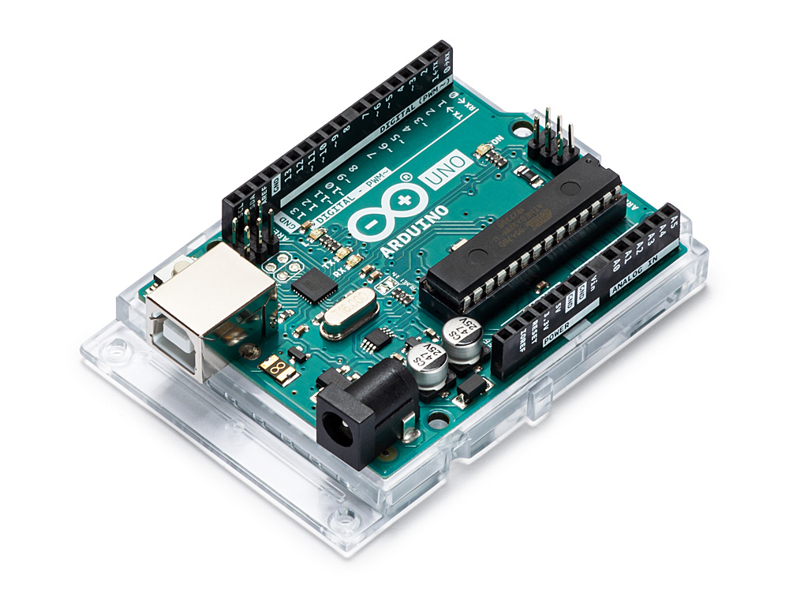

Fig.1 The Arduino UNO R3

1. *HC-SR04 Ultrasonic Sensor:*

Ultrasonic Sensor HC-SR04 emits an ultrasound that travels through the air and bounces back to the module if an object or obstacle is on its path. The module consists of a transmitter and a receiver. The distance is calculated using the travel time and the speed of the sound. Specifications: i. 4 Pins (VCC, TRIG, ECHO and GND), ii. 5V Supply Voltage, and iii. 40kHz Sonar.

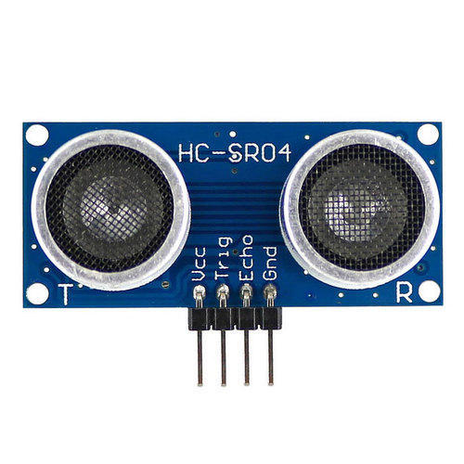

Fig.2 The HC-SR04 Ultrasonic Sensor

1. *Micro Servo 9G (SG90):*

It is an Industry-standard miniature RC servo, commonly used in light-weight RC

drones, planes, or helicopters. Standard SG90 miniature size makes it great and convenient for use with microcontroller mechatronic projects and is compatible with Arduino. Features 180 degrees of rotation with 0.125oz-in of torque.

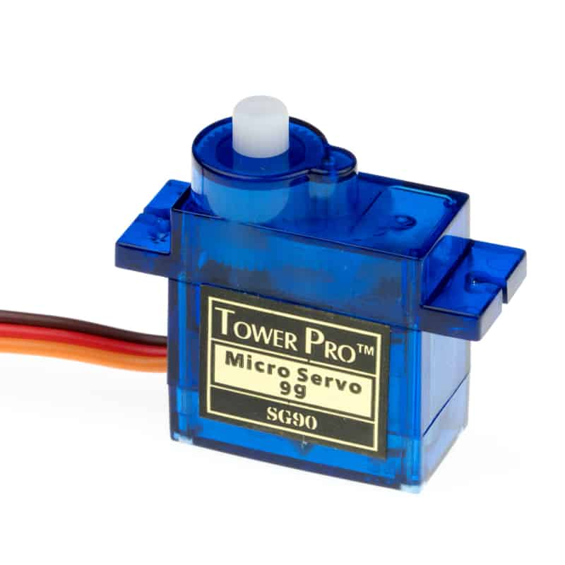

Fig.3 The Micro Servo 9G

1. *Coloured Wire Jumper Cables:*

A jump wire (also known as jumper, jumper wire, jumper cable, DuPont wire or cable) is an electrical wire, or group of them in a cable, with a connector or pin at each end (or sometimes without them – simply "tinned"), which is normally used to interconnect the components of a breadboard or other prototype or test circuit, internally or with other equipment or components, without soldering.

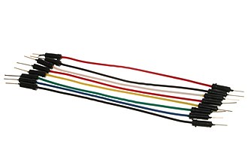

Fig.4 Coloured Wire Jumper Cables

1. *9V Battery with Battery Snap Connector:*

The nine-volt battery, or 9-volt battery, is a common size of battery that was introduced for early transistor radios. It has a rectangular prism shape with rounded edges and a polarized snap connector at the top. This type is commonly used in smoke detectors, gas detectors, clocks, walkie-talkies, electric guitars and effects units. The battery has both terminals in a snap connector on one end. The smaller circular (male) terminal is positive, and the larger hexagonal or octagonal (female) terminal is the negative contact. The connectors on the battery are the same as on the load device; the smaller one connects to the larger one and vice versa.

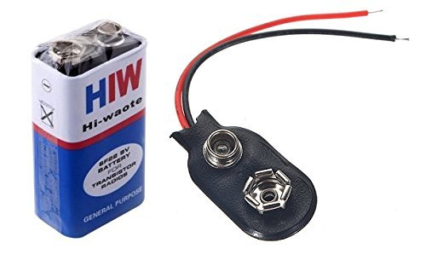

Fig.5 Nine-volt battery with snap connector

1. *Working*

The servo motor is attached to the lid and the ultrasonic sensors are positioned at the front. The dustbin uses an Ultrasonic sensor HC-SR04 to detect objects in front. It sends the signals to Arduino Uno. The Arduino processes them and commands the servo motor to open the dustbin's lid. The time for the lid to stay open can be changed as per requirements by editing the code on the Arduino IDE. The sensor's 'ECHO' and 'TRIG' are connected to Arduino Uno's pins' 5' and '6', respectively. The 'VCC' pin is connected to '5V' on Arduino Uno, and both the grounds are connected. The 9V battery has been connected to the 'VIN' pin on the Arduino Uno, with the grounds connected.

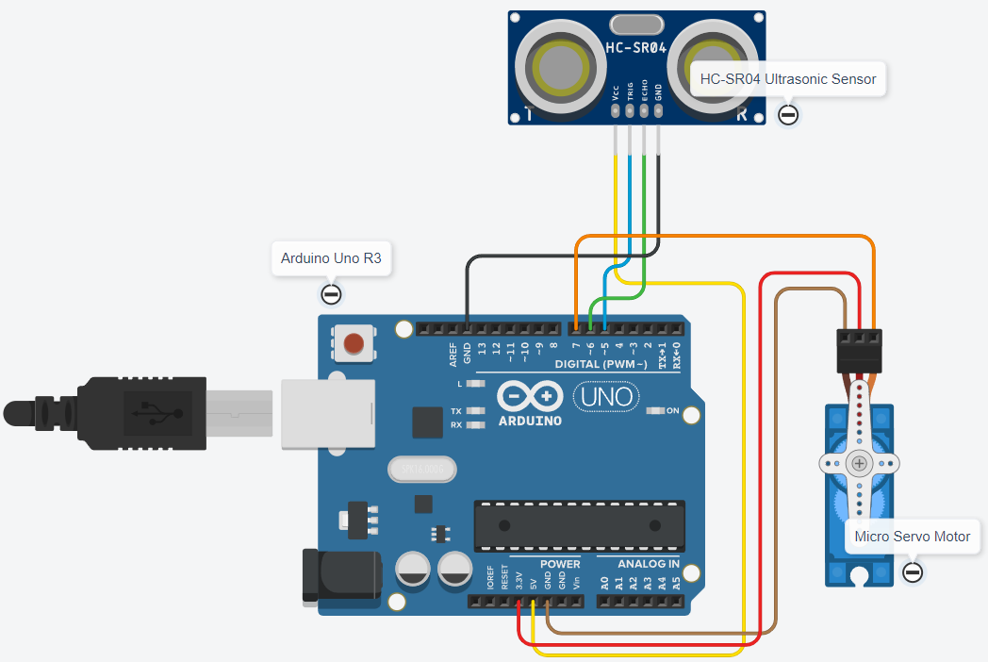

Fig.6 Circuit diagram of the project

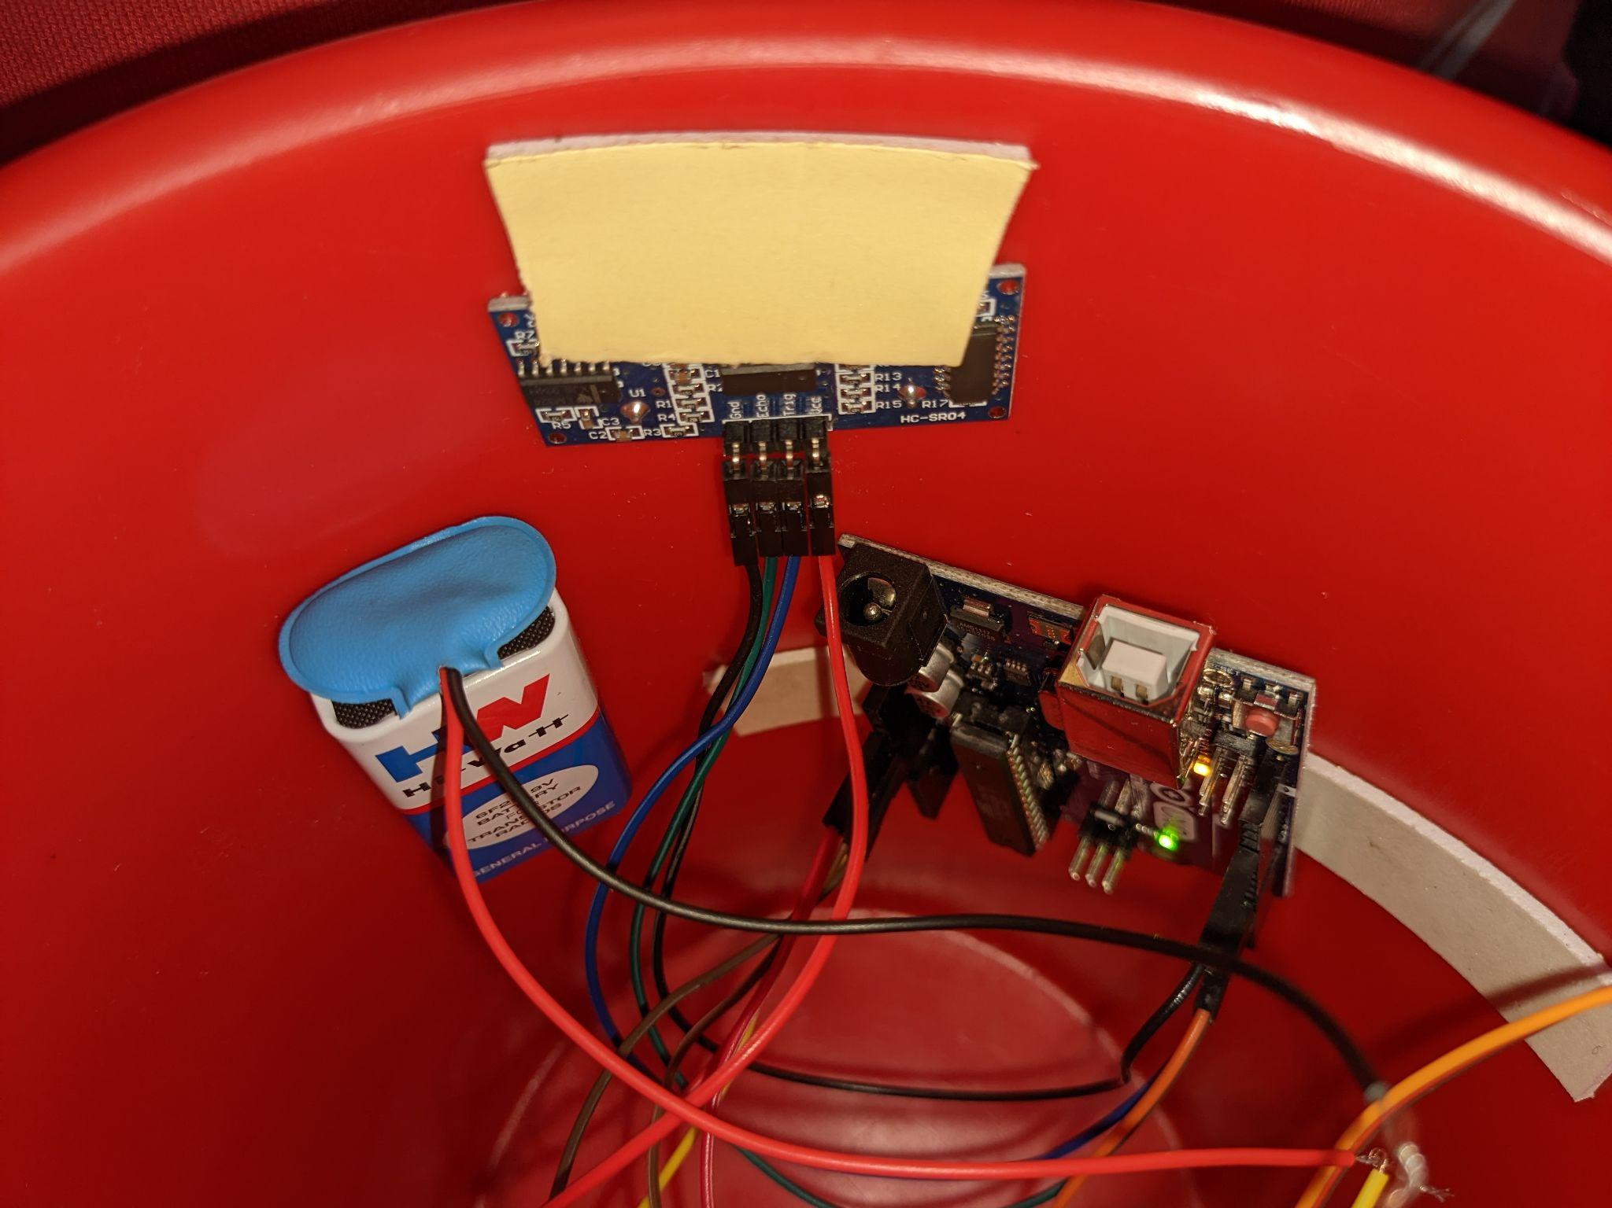

Fig.7 Circuit connections inside the dustbin

IV. RESULT AND CONCLUSIONS

The proposed work successfully created a smart garbage bin that automatically opens and closes its lid whenever anyone approaches it with the garbage. This process is very quick and does not take much time to trouble its user. Use of this smart dustbin avoids any kind of physical contact with the dustbin body. So, no direct exposure to the germs. Thus, this paper concludes that the smart garbage collectors are very useful and safe.

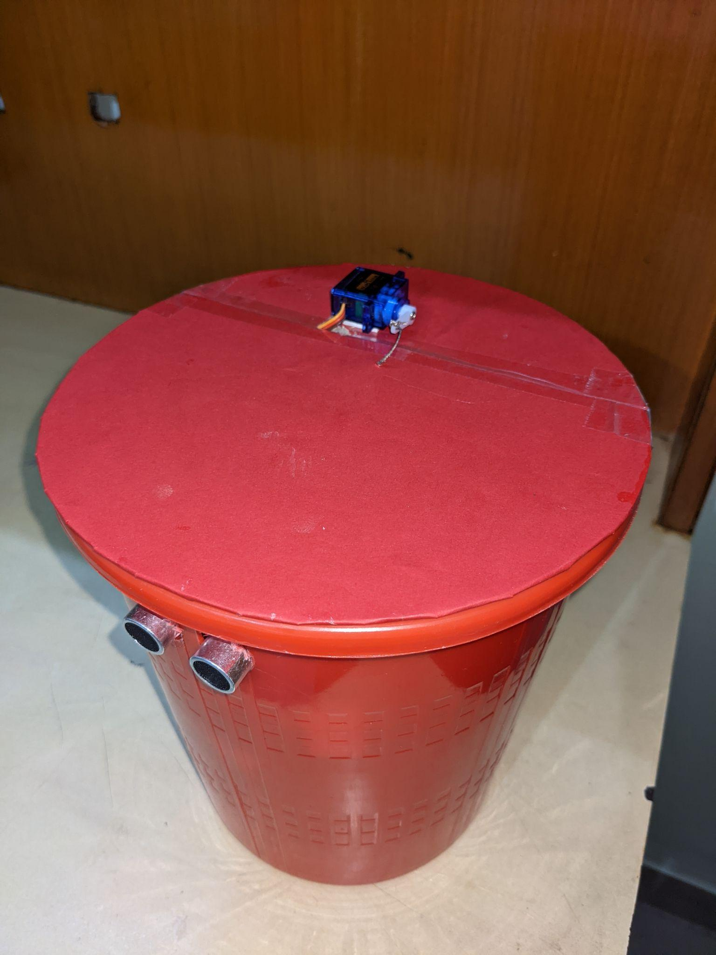

Fig.8 Dustbin with the servo motor and ultrasonic sensor

V. LIMITATIONS

Though the proposed work is a successful smart garbage bin it has certain limitations. Firstly, it cannot detect the garbage thrown outside but near the bin. Secondly, it is unable to distinguish between dry and wet garbage. Thirdly, there is no scope to know when the bin reaches its maximum capacity of storing waste.

VI. FUTURE SCOPE

The limitations of the proposed work can be easily overcome by simple modifications in the model. An infrared sensor can be used to detect the garbage thrown on the ground near the garbage bin and it will switch ON the buzzer. Also, a moisture sensor can be used to distinguish between dry and wet waste. Naturally, the moisture content of wet waste would be more.

REFERENCES

[1] C. Kolhatkar, B. Joshi, P. Choudhari and D. Bhuva, "Smart E-dustbin," 2018 International Conference on Smart City and Emerging Technology (ICSCET), 2018, pp. 1-3, doi: 10.1109/ICSCET.2018.8537245.

[2] G. S. Rohit, M. B. Chandra, S. Saha and D. Das, "Smart Dual Dustbin Model for Waste Management in Smart Cities," 2018 3rd International Conference for Convergence in Technology (I2CT), 2018, pp. 1-5, doi: 10.1109/I2CT.2018.8529600.

[3] Asyikin, A. N., & Subandi, A. A. S. (2020, November). Design and Implementation of Different Types of Smart Dustbins System in Smart Campus Environments. In *International Joint Conference on Science and Engineering (IJCSE 2020)* (pp. 1-7). Atlantis Press.

[4] P. Sharma, P. Kumar, R. Nigam and K. Singh, "Automatic Waste Segregating and Self Sanitizing Dustbin," 2020 2nd International Conference on Advances in Computing, Communication Control and Networking (ICACCCN), 2020, pp. 368-372, doi: 10.1109/ICACCCN51052.2020.9362729.

[5] Sakshi, J., Hardika, L., Ishika, A., & Lodha, G. M. (2019). Survey Paper on ‘Smart Dustbin Management System’. *Journal of Advancement in Software Engineering and Testing*, *2*(2).

[6] J. Ghorpade-Aher, A. Wadkar, J. Kamble, U. Bagade and V. Pagare, "Smart Dustbin: An Efficient Garbage Management Approach for a Healthy Society," 2018 International Conference on Information , Communication, Engineering and Technology (ICICET), 2018, pp. 1-4, doi: 10.1109/ICICET.2018.8533851.

[7] Murugaanandam, S., Ganapathy, V., & Balaji, R. (2018, April). Efficient IOT based smart bin for a clean environment. In 2018 International Conference on Communication and Signal Processing (ICCSP) (pp. 0715-0720). IEEE.

[8] E.Rao, P. V., Azeez, P. M. A., Peri, S. S., Kumar, V., Devi, R. S., Rengarajan, A., ... & Praveenkumar, P. (2020, January). IoT based Waste Management for Smart Cities. In *2020 International Conference on Computer Communication and Informatics (ICCCI)* (pp. 1-5). IEEE